# 



**E-Commerce project**

**LIBERTY ELECTRONICS**

|  |  |
| --- | --- |
| **Authors** | C2108L_Group 01 |
| NGO QUANG VINH  DO THIEN QUAN  NGUYEN HAI SON  NGUYEN MINH NHAT |
| **Date** | **01/08/2022** |
| **Instructor** | **NGUYEN VAN TUAN** |

**Acknowledgement**

Our e-Project 1 needs assistance to be done and we, the authors, would like to give our acknowledgement to those who have supported and motivated us during the period of implementing this e-Project 1.

First and foremost, we would like to thank our instructor Mr. **NGUYEN VAN TUAN** whose support and useful advices helping us to complete our e-Project 1 effectively. His encouragement and comments had dramatically enriched and improved our work.

Secondly, we would like to thank Aprotrain - Aptech Computer Education, teachers, and staffs for their support throughout our learning and completing this e-Project 1.

Thirdly, we would like to thank our families’ members including our parents, spouses and siblings for their support and care all the time, especially in the period of completing our work.

Lastly, our deep thanks to all our classmates during studying time in Aptech. Their kind help, care, and motivation help us conquer the higher targets in the future.

**1.** **Problem Definition**

1.1 ***Problem Abstraction***

“LIBERTY ELECTRONICS” is one of the leading electronics distributors and suppliers. They sell them under different brand names. The quality of products is famous for the technologies, features, and utilities that they bring to users. Shop owners want to have an e-store website where they want to describe all types and brands of products.

1.2  ***The Current System***

Nowadays, electronic devices have played an important role in people's lives. It is not only used for entertainment but also used as an indispensable tool in human life.

The most specific example of electronics is that they are used a lot everywhere in the world, as it can now be used in almost any job. For example, a phone can control a house, call and text people miles away, etc.

Therefore, "LIBERTY ELECTRONICS" was born in order to support customers to access the latest technology items with a very reasonable price. . .

With quality put first, professional sales team, perfect service, reasonable price, “LIBERTY ELECTRONICS” always receives the trust and appreciation of partners and customers.

1.3 ***The Proposed System***

The new system will be built on a web application platform that helping to communicate with customers on the internets, providing customers with a comprehensive view and knowledge of the types of technologies and utilities that electronic devices provided by from different brands.

The website's homepage will have a Category Menu for navigating around the site, which describes all the major sections of the site such as product’s category and their brands. Furthermore, the homepage also illustrates the latest developments in electronic technology and showcases some popular products.

In the specific category, the product page shows the product information available and displayed in the store. The category page provides information for individual electronic items such as phones, smartwatches, tablets, and more. The product details page provides detailed product information such as price, availability, color and capacity...

1.3.1 ***Boundaries of the System***

The website provides information on 4 types of product included: cellphone, smartwatch, earphone, tablet,etc that support customers in finding and choosing the right product with their needs. In addition, customers can use all the information for reference.

1.3.2 ***Hardware and Software Requirements***

**Hardware:**

•The minimum system requirement to host the website and allow user to access all functions is a computer with an Intel Core™ i3 processor or equivalent.

• System has at least 2GB RAM, 8GB RAM is recommended.

• 1GB free of disk space, 512GB solid state drive (SSD) is recommended for the best performance.

**Software:**

• Windows Server 2012, Windows 7 or higher version.

• A server software (XAMPP, LAMPP…) with MySQL database management.

• An up-to-date browser (e.g., Google Chrome, Microsoft Edge, Safari, Firefox, and so on.)

**2.** **Customer Requirements Specification**

2.1 ***Users of the System***

The system can be used by customers and administrators.

- Customers are users who are allowed to visit the main website where they can view and interact with the information (such as product details, brands, color, prices and others). Customers can register as Members to place orders to purchase goods and compare different types of products.

- Administrators are salespeople, affiliates, also known as users who have access to administrative tools to provide their products and services, or simply make calls consultation appointment with the clients. Administrators should be divided into 2 groups for security reasons.

2.1.1 Customers

◉ Have the right to view and find products

◉ Have the right to give feedback

◉ Have the right to add products to cart

◉ Increase/decrease the number of products in the cart

◉ Have the right to remove the products from cart

◉ Have the right to compare different types of products

◉ Register as a member.

◉ Order and pay (Members only)

2.1.2 Administrators

◉ Have the right to manage products (add, edit status)

◉ Have the right to manage product categories (add, edit status)

◉ Have the right to manage administrative account (add, change type, disable)

◉ Have the right to manage order (process, change order status)

◉ Have the right to manage photo gallery (add, delete)

◉ Have the right to manage customer feedback (read)

2.2 ***System functions***

2.2.1 Homepage

+ Description: with customers who visit website for the first time, the homepage is divided into 4 sections:

- About us: about the Company

- Main categories: introduce 3 main categories such as all products, products by brand, products by category of product.

- Contact us: location of the company on geolocation (using Google Maps), leave comments and suggestions with the company

- Navigation bar: Show cart, comparison and login page as well as search bar

2.2.2 Products page

+ Description: For users who want to take a look at all kinds of products. There will be product illustrations, specific product prices, and buttons to add the products to the cart or compare page.

+ Display: product name, product image, price, brand, availability, etc.

2.2.3 Function To View details of each product type

+ Description: For customers who want to access full information of the product, such as name, detailed description,…

+ Processing: Export from database using product #id with details: name, image, description, color in stock, storage in stock.

+ Display: Detailed information of each product.

2.2.4 Contact Us Function

+ Description: For those who want to give comments, reviews, or feedback on the problems.

2.2.5 About Us Function

+ Description: introduction about the company.

2.2.6 Search Function

+ Description: For users who want to search for product information by name or category or problems.

+ Display: the product that match the search query.

2.2.7 Login Function

+ Description: For users who want to add the product to their cart.

+ Display: registration link, login by email, password.

2.2.8 Administrative functions

Login function:

+ Description: For administrators to access the Administration functions, access to all functions, products and order processing functions.

+ Input: Username and password.

+ Processing: Retrieve the database and check if the account exists or not, the password is correct or not, and the status of the account. If the user's account has been locked by an administrator, deny them to login.

+ Display: Login interface including account and password.

+ Flowchart:

2.2.9 Product Add Function:

+ Input: Enter product information such as: name, price, image, product description.

+ Processing: Add the information just entered to the database.

+ Flowchart:

2.2.10 Function to Recycle product:

+Enter: Admin can delete or recycle added products.

2.2.11 Function to add new brands:

+ Enter: The administrator can add new brands for new product line.

+ Processing: validate the input of the brands such as name, if valid add brand to database , if not: display an alert.

+ Privilege: only admin tier 1 can access this function

2.2.12 Function to add new category:

+ Enter: The administrator can add new category for new product line.

+ Processing: validate the input of the category such as name, description… if valid add the new product category to the database, if not: display an alert.

+ Privilege: only admin tier 1 can access this function

2.2.13 Function to add new storage

+ Enter: The administrator can add new storage for new product line.

+ Processing: validate the input of the storage such as name, if valid add the new storage to the database, if not: display an alert.

+ Privilege: only admin tier 1 can access this function

2.2.14 Function to add new color

+ Enter: The administrator can add new color for new product line.

+ Processing: validate the input of the color such as name, if valid add the new color to the database, if not: display an alert.

+ Privilege: only admin tier 1 can access this function

2.2.15 Function to Edit product and add image to Detail product

+Enter: Edit or add new product detail images

+Handling: Check the new image for correct product information, if valid, replace the old image, if not, keep it and display a warning.

2.2.16 Function to create new user account

+Enter: The administrator can create new user account

+Process: Enter username, email and password,(requires password confirmation), phone number, address and select account type (admin or user), validate all information. If the information is valid, create a new user account, otherwise: show a warning message.

+Privilege: Only admin tier 1 can access this function.

2.2.17 Function to edit user account

+Enter: The administrator can alter any user account.

+Processing: Change username, email, password, phone number, address, account type, account status and reset password of any account

+Privilege: Only administrator tier 1 can access this function.

**3.** **System Designs**

3.1 ***Entity Relationship Diagram***

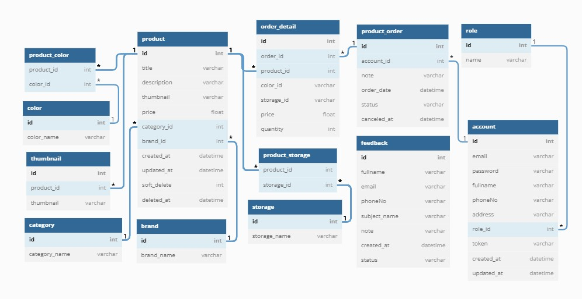

3.2 ***Database Design***

Tables detail description:

- Account table including:

+ id: int(11)data type, primary key

+ email: varchar(255) data type.

+ password: varchar(255) data type.

+ fullname : varchar(255) data type.

+ phoneNo: varchar(255) data type.

+ address: varchar(255) data type.

+ role_id: : int(11) unsigned data type, foreign key to role(id)

+ token: varchar(255) data type

+ created_at: datetime data type

+ updated_at: datetime datatype

-- Role table including:

+ id: int(11) data type,primary key

+ name: varchar(255) data type

- Feedback table including:

+ id: int(11) data type,primary key

+ fullname: varchar(255) data type

+ email: varchar(255) data type

+ phoneNo: varchar(255) data type

+ subject_name: varchar(255) data type

+ note: varchar(255) data type

+ created_at: datetime data type

+ updated_at: datetime datatype

- Product table including:

+ id: int(11) data type,primary key

+ title: varchar(255) data type

+ description: varchar(255) data type

+ thumbnail: varchar(255) data type

+ price: float data type

+ category_id: int(11) data type, foreign key to category(id)

+ brand_id: int(11) data type, foreign key to brand(id)

+ created_at: datetime data type

+ updated_at: datetime data type

+ soft_delete: int(11) data type

+ deleted_at: datetime data type

- Category table including:

+ id: int(11) data type,primary key

+ category name: varchar(255) data type

- Storage table including:

+ id: int(11) data type,primary key

+ storage_name: varchar(255) data type

- Product_storage table including:

+ product_id: int(11) data type,primary key, foreign key to product(id)

+ storage_id: int(11) data type, foreign key to storage(id)

- Brand table including:

+ id: int(11) data type,primary key

+ brand_name: varchar(255) data type

- Thumbnail table including:

+ id: int(11) data type,primary key

+ product_id: int(11) data type , foreign key to product(id)

+ thumbnail: varchar(255) data type

- Color table including:

+ id: int(11) data type,primary key

+ color_name: varchar(255) data type

- Product_color table including:

+ product_id: int(11) data type ,primary key, foreign key to product(id)

+ color_id: int(11) data type , foreign key to color(id)

- Order_detail table including:

+ id: int(11) data type,primary key

+ order_id: int(11) data type , foreign key to product_order(id)

+ product_id: int(11) data type, foreign key to product(id)

+ color_id: int(11) data type

+ storage_id : int(11) data type

+ price: float data type

+ quantity: int(11) data type

- Product_order table including:

+ id: int(11) data type,primary key

+ account_id: int(11) data type , foreign key to account(id)

+ note: varchar(255) data type

+ order_date: datetime data type

+ status: varchar(30) data type

+ canceled_at: datetime data type

3.3 ***Sitemap***

3.4 ***System functions design***

3.4.1 User Interface

* Login Form

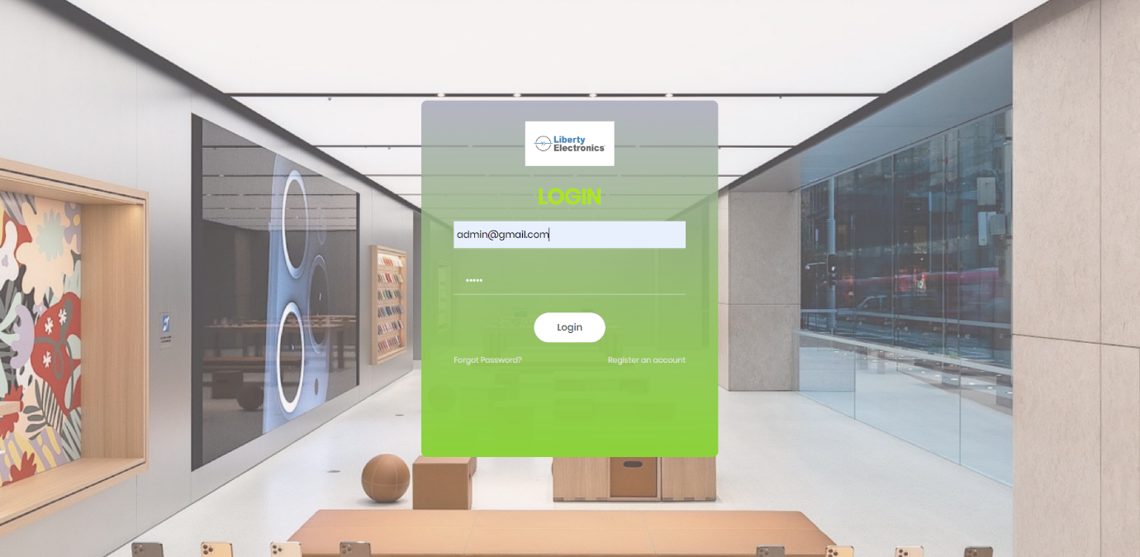

* Home Page

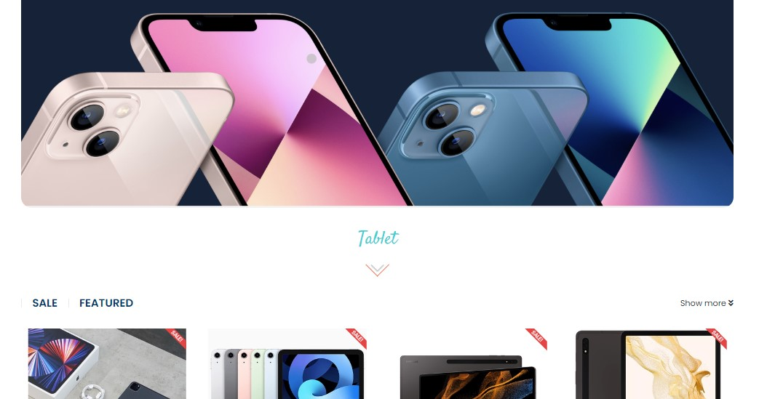

* Product

* Brand

* Category

* Product Detail

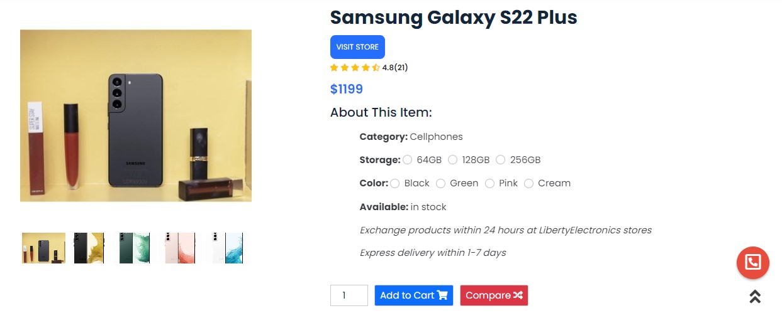

* Contact us

* About us

* Bill cart

* Compare

3.4.2 Admin Interface

* Login Page

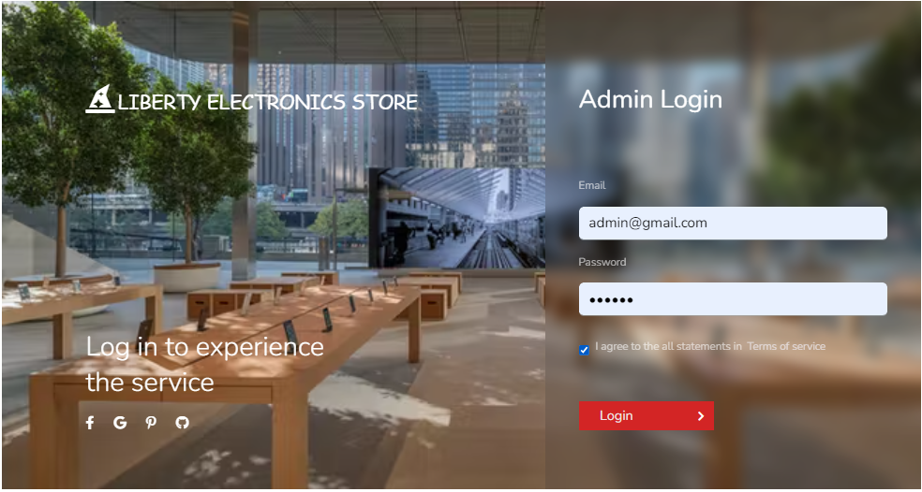

* Admin Information

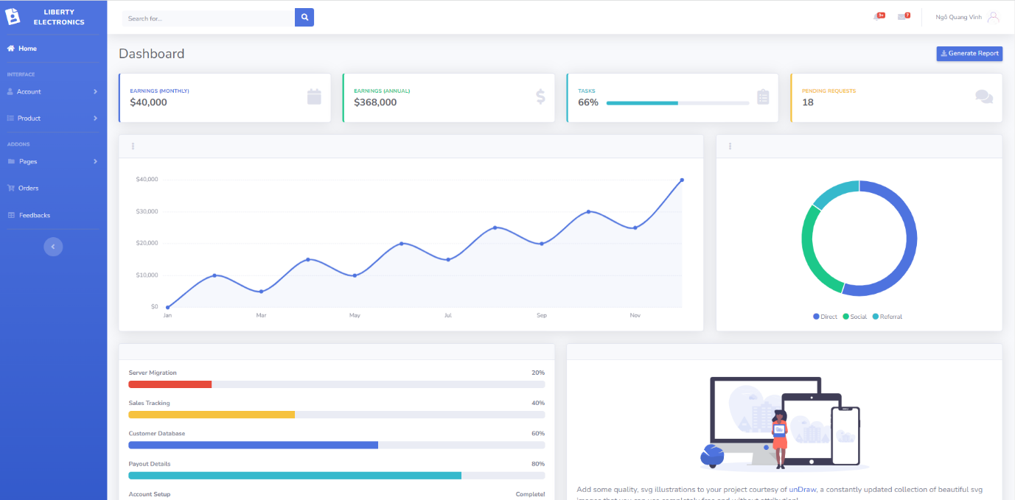

* User information

* Create New Account

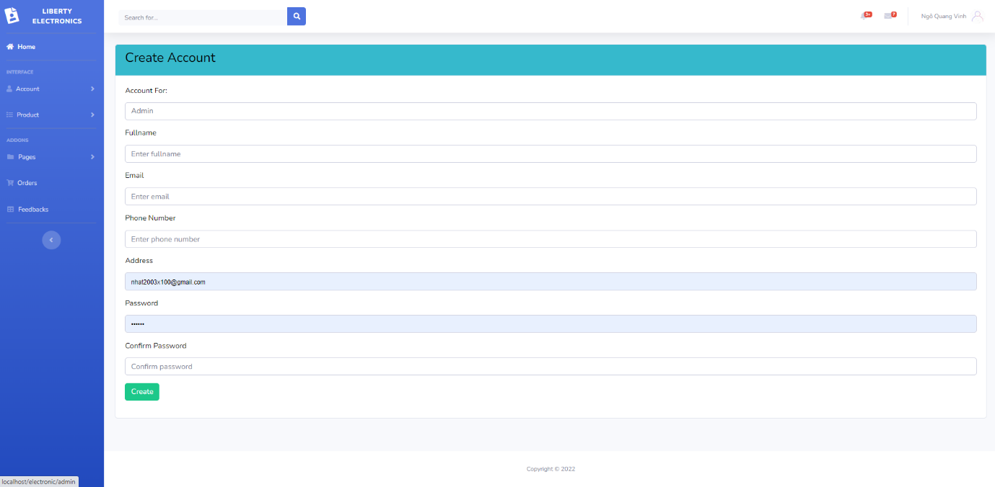

* Products

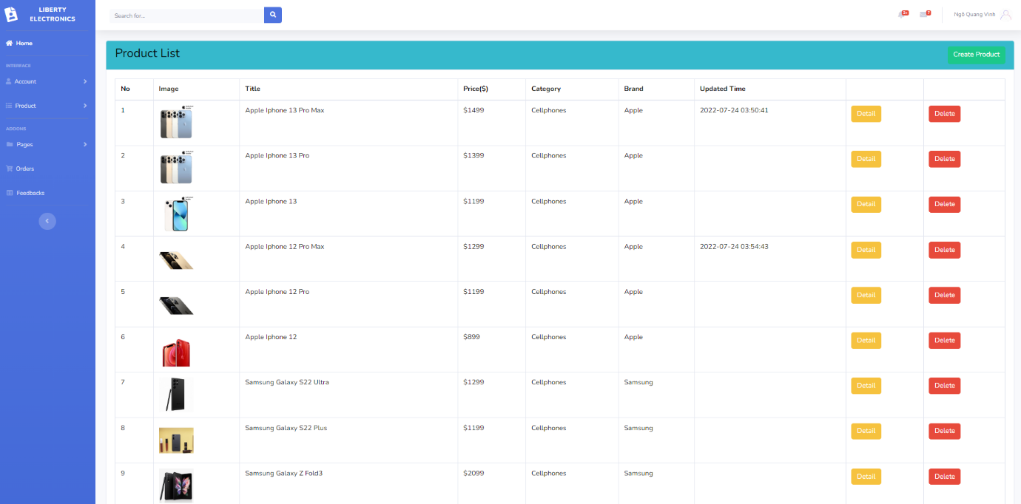

* Create new product

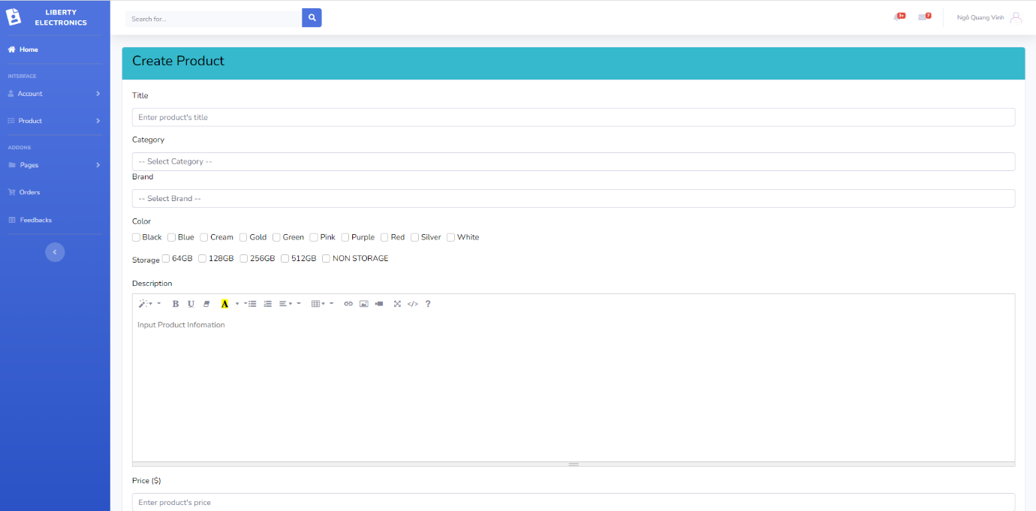

* Pages Management
  + Brand

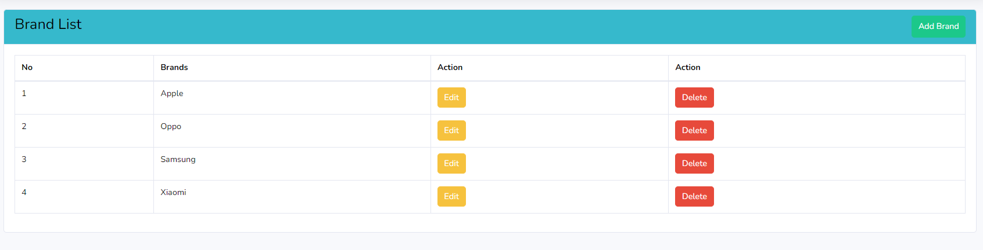

* + Category

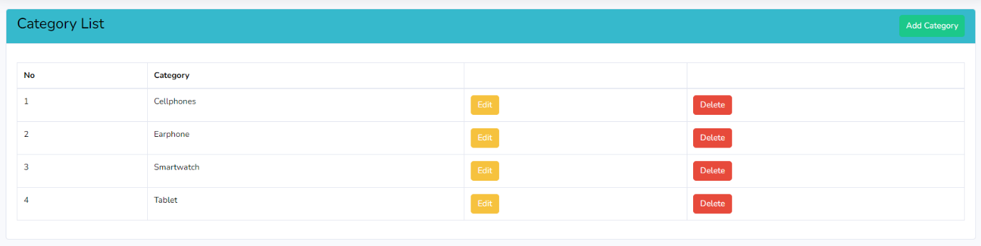

* + Color

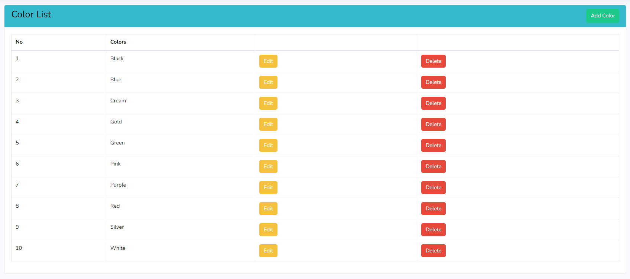

* + Storage

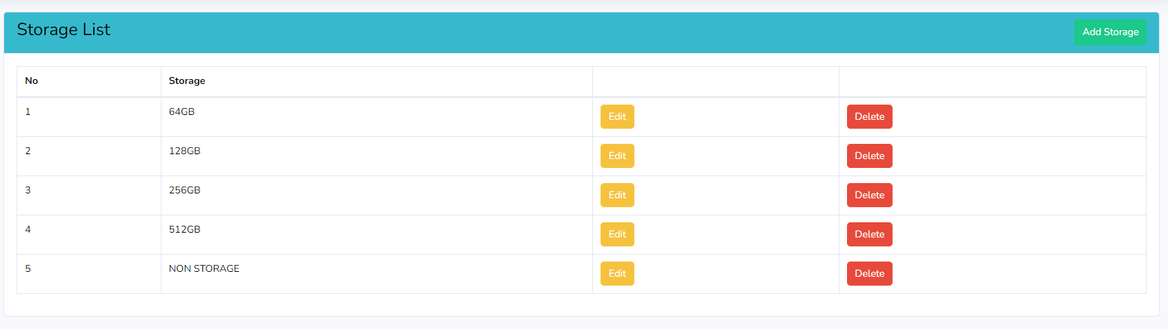

* Order

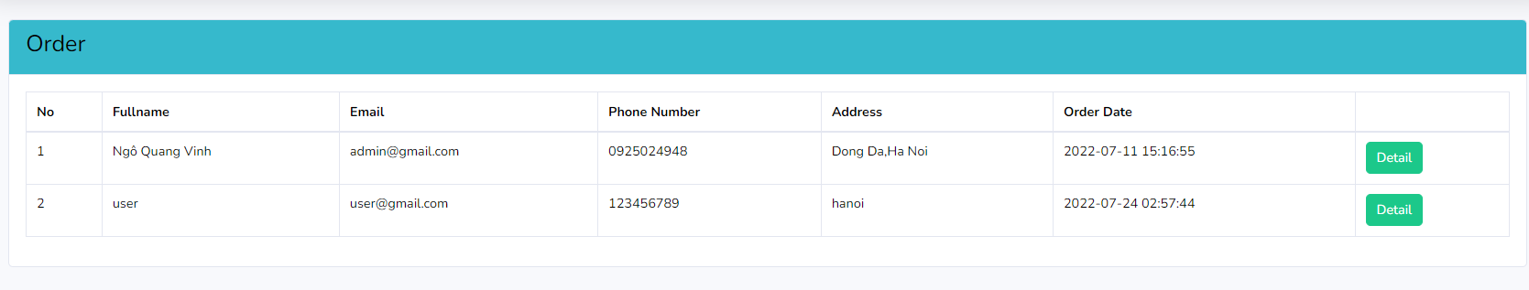

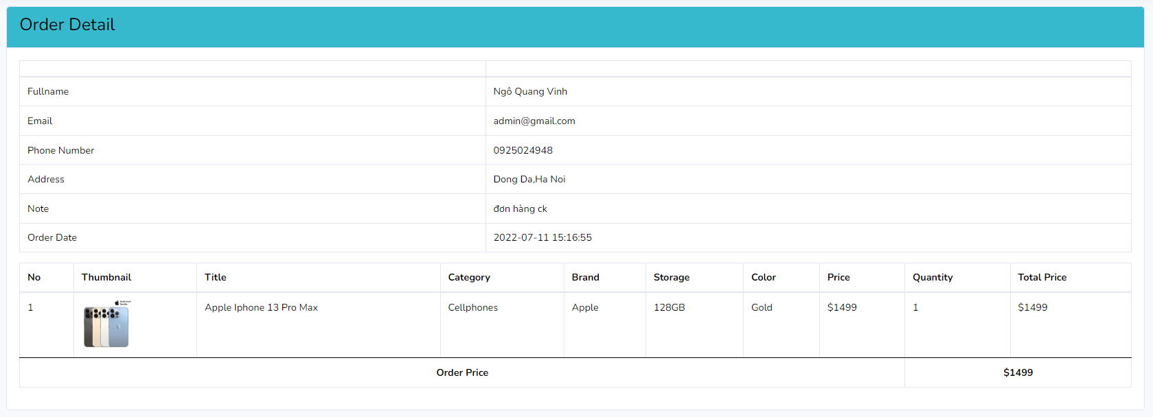

* Feedbacks

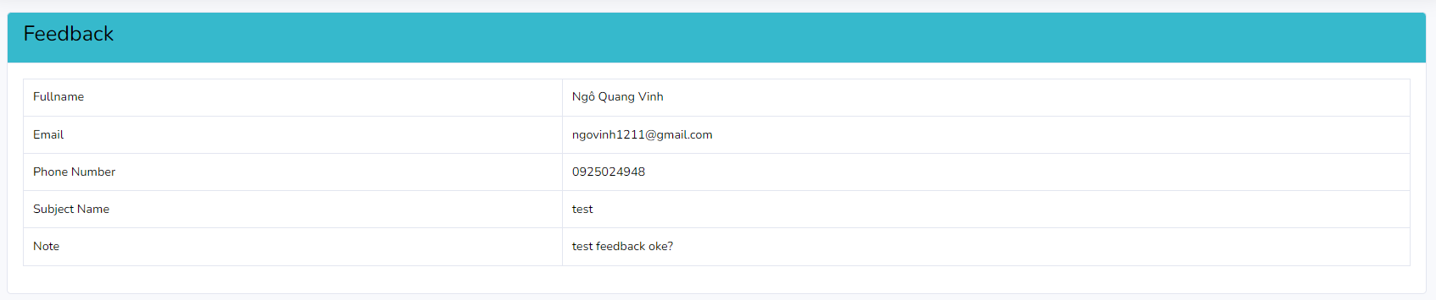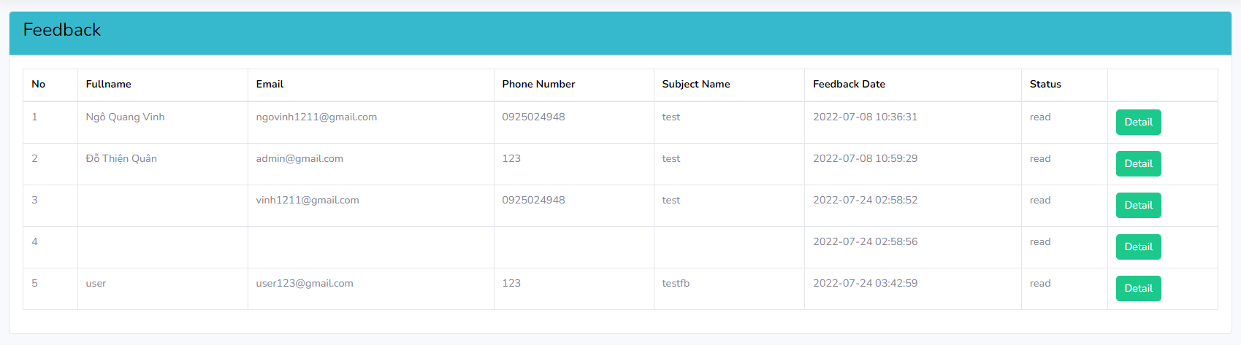

**4.** **Task sheet**

